**Programming Project #3**

**Part 1: OS User Administration**

**(1) Create an administrator user account with username *“jchen”* and a password of your choice.**

Go to **Start 🡪 Control Panel**

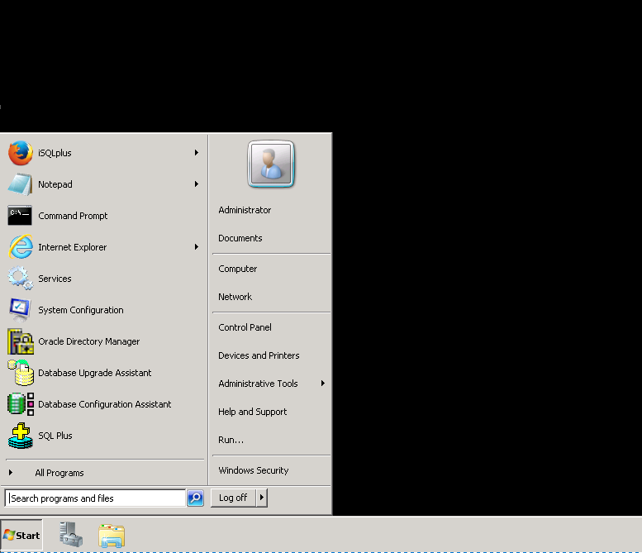

In Settings, go to **User Accounts**

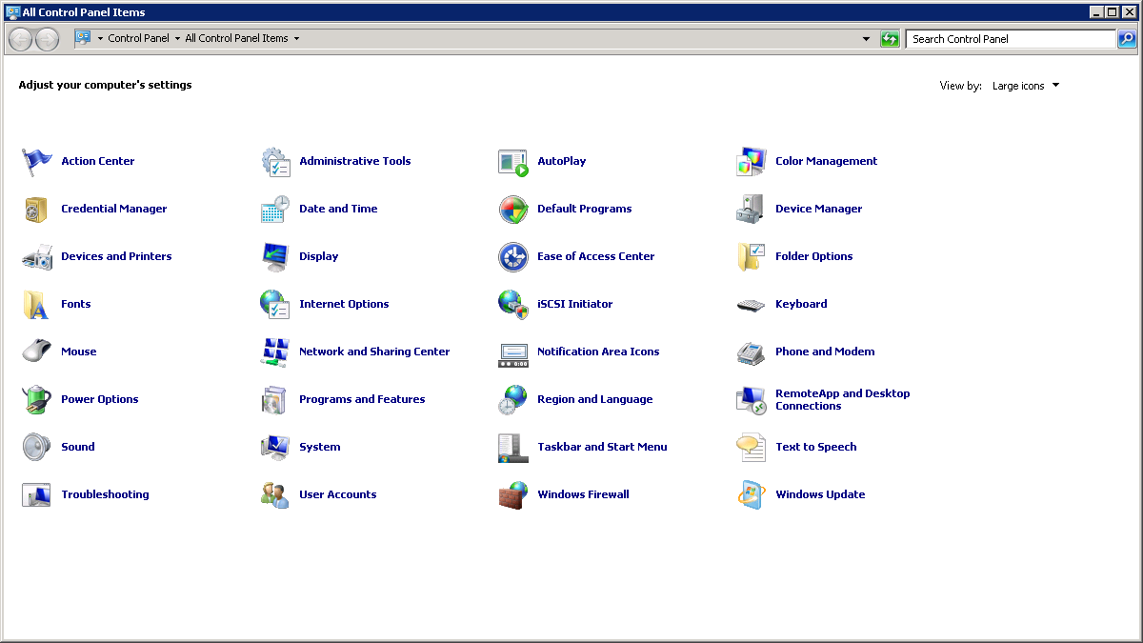

In User Accounts window, on the left side select **Manage another account**

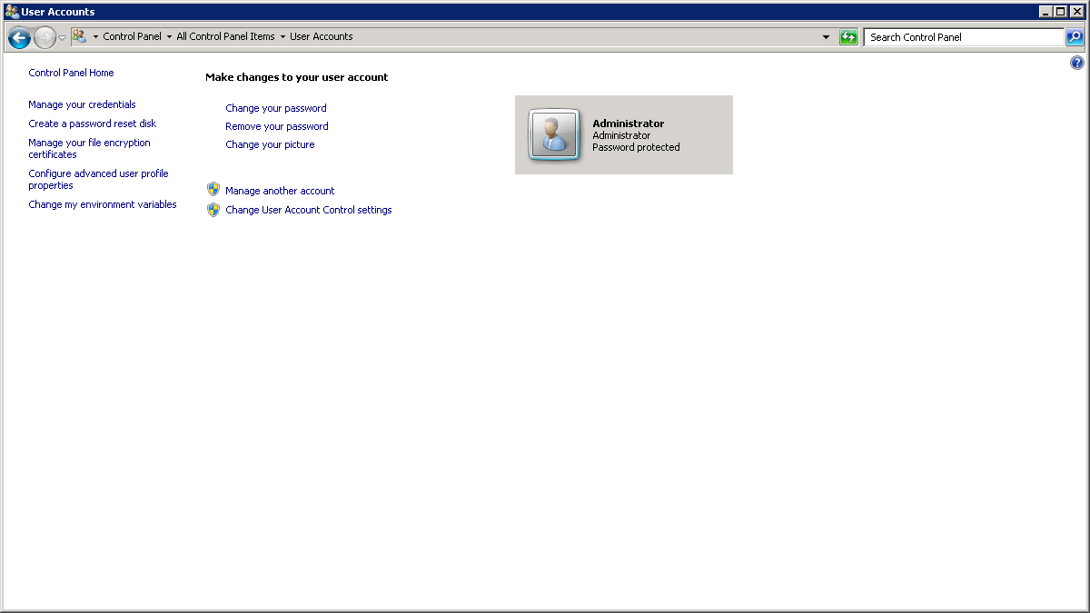

In the Manage Accounts window, Click on **Create a new account**

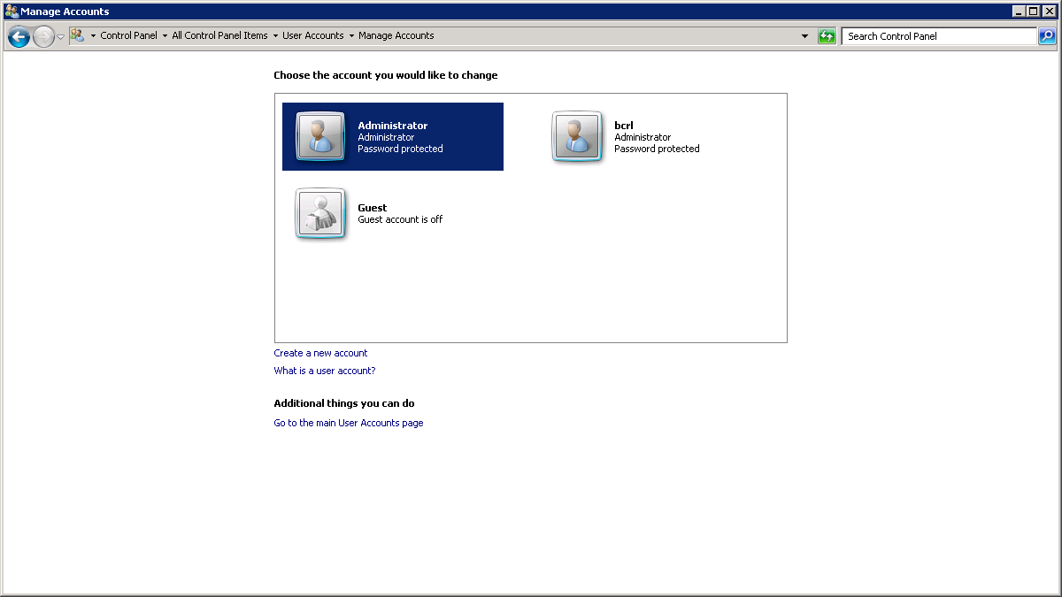

In the following screen, enter user name as ***“jchen”*** and select **Administrator** and click **Create Account**

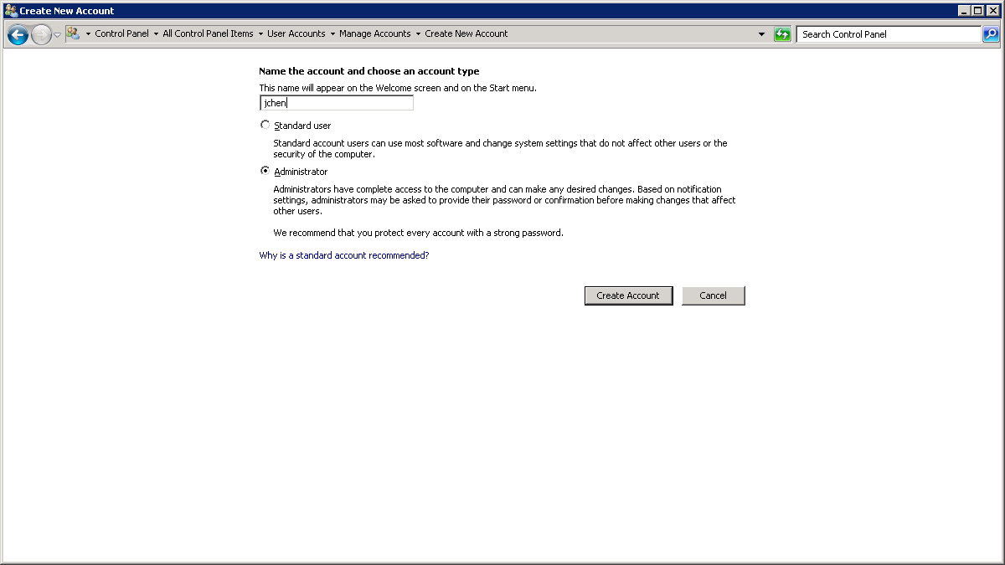

An account with user name ***“jchen”*** will be created with administrator privileges

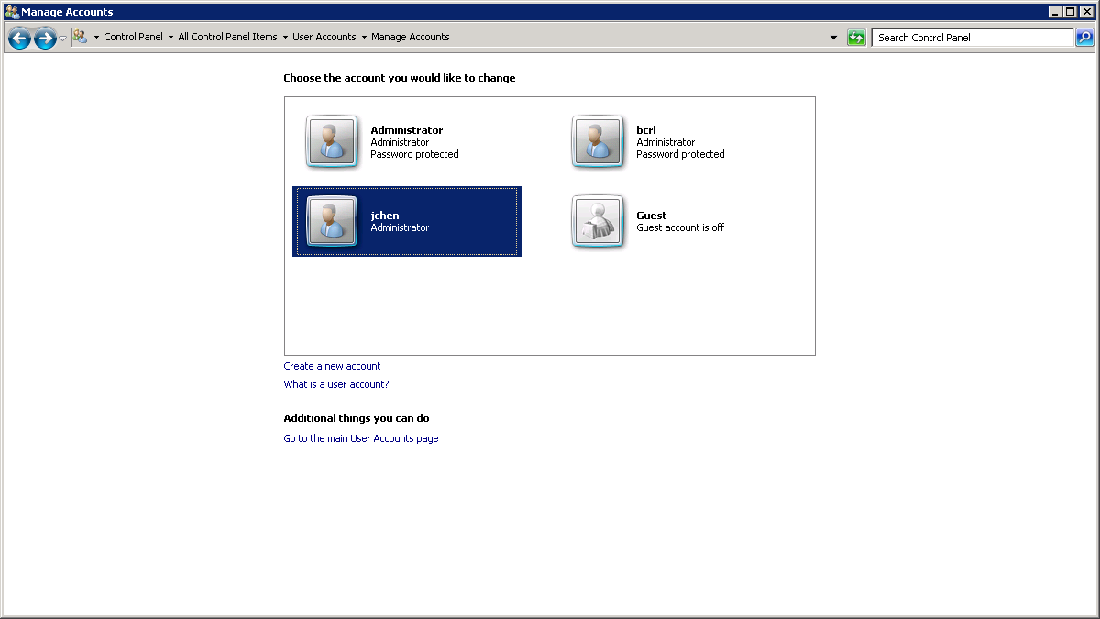

Click on ***“jchen”*** account to create a password for that account

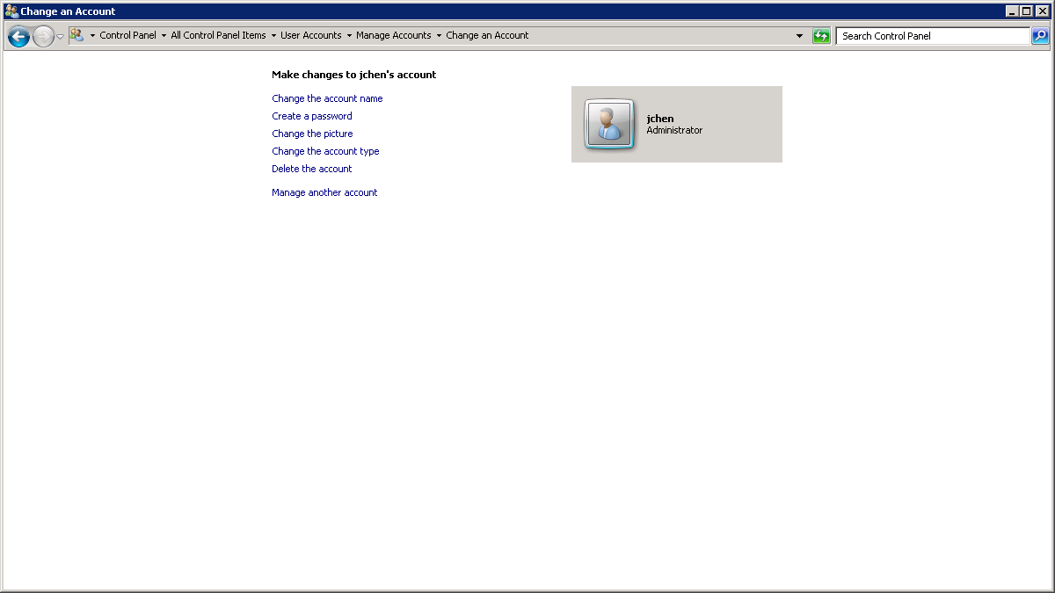

Click on **create a password** to get the following screen, enter a **password** of your choice and hint for the password and then click on create password.

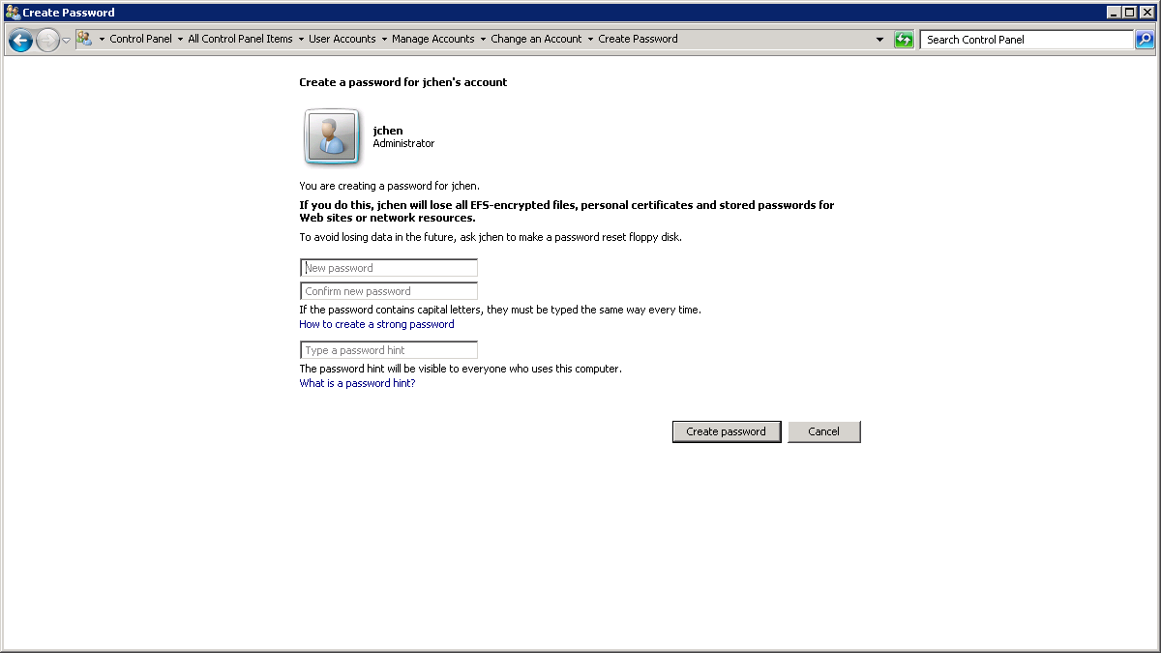

A password protected administrator account with username jchen will be created.

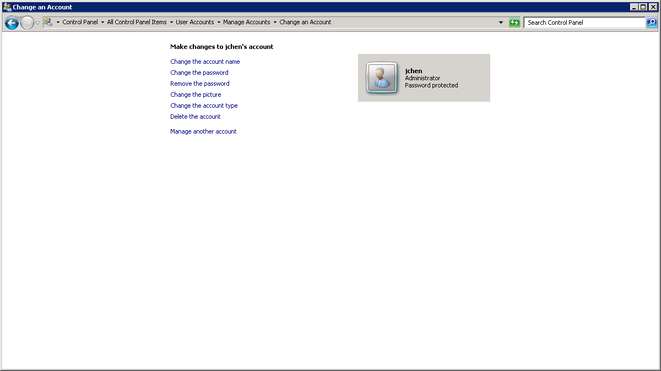

**(2) Add jchen to the remote desktop access list.**

Go to Start 🡪 Control Panel 🡪 System

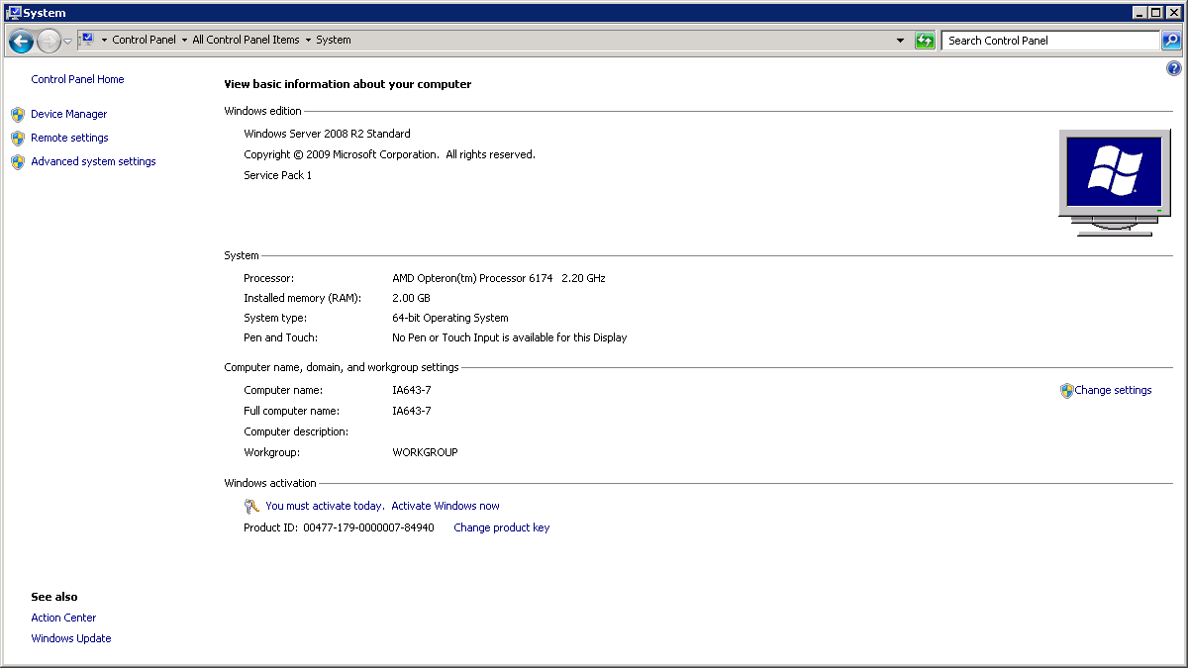

On the left side of the window, select **Remote** settings, System Properties window will open. Select **Allow connections from computers running any version of Remote Desktop** and click on **Select Users** button

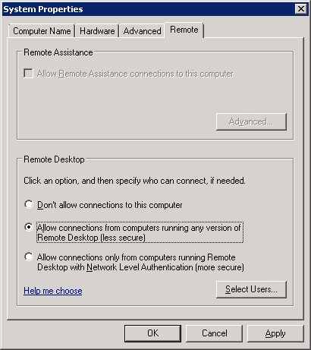

**Remote desktop users** window will open. Click on **Add** button.

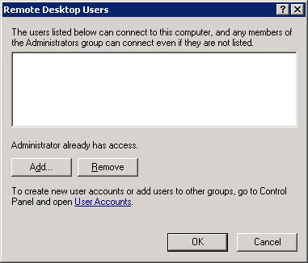

**Select users** window will open. Click on **Advanced** button.

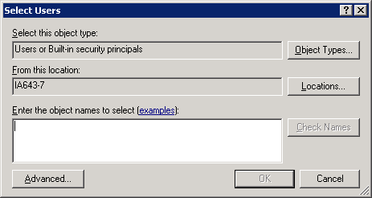

In the new window, click on **Find Now** button to get the list of all the users, select ***jchen*** from the list and click **OK**

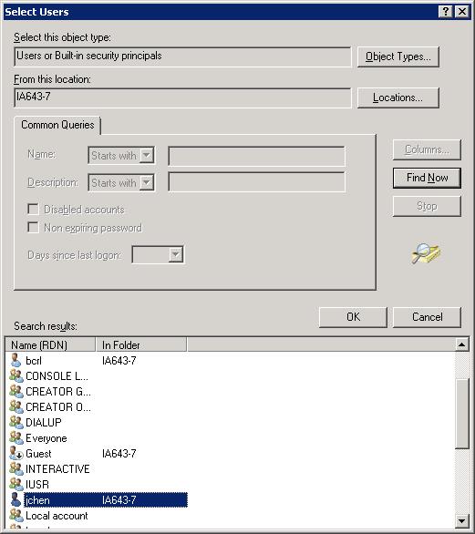

Click **OK** on **select users** window, you can see that **jchen** has been added to the **remote desktop users** window then click **OK**.

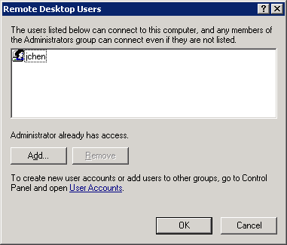

Then Click **OK** in the **System properties** window.

**(3) What’s the OS’s password minimum complexity requirements?**

Go to **Start 🡪 Control Panel 🡪 Administrative Tools 🡪 Local Security Policy 🡪 Account Policy 🡪 Password Policy**

This path will take you to the following screen:

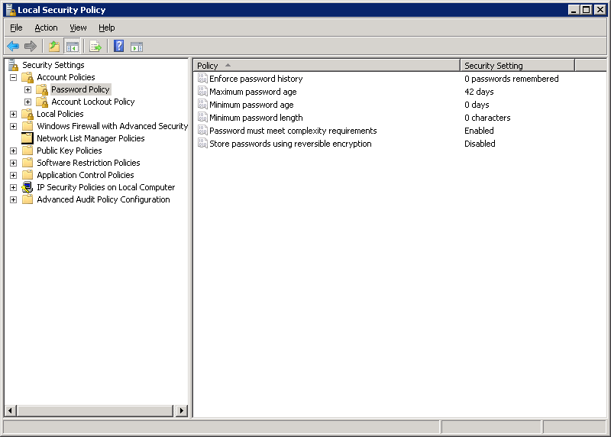

Right side you can see the **Password must meet complexity requirements**. By double clicking on this policy, a new window will open. Go to explain tab in that window, you can see the password complexity requirements.

